Discussion Assignment 1
#Question 1:
The graph of $y = sin x + cos x$ has a sinusoidal shape. Having two periodic functions (both cosine and sine) makes it a periodic function. Finally, the overall shape of this function oscillates between maximum and minimum values.
#Question 2:
Below is the graph of $y=3sinx$ for $-2π≤x≤2π$.
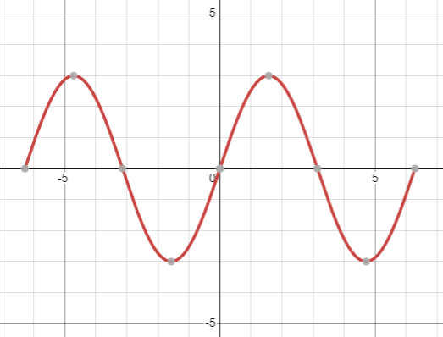
From the graph, maximum point occurs at $x=-2π$, $x=2π$, and $y=3$.
#Question 3:
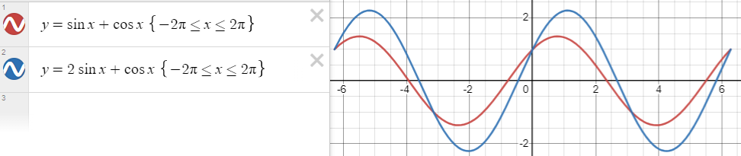
From the figure above, the graph for $y = 2sin x + cos x$, where $A = 2$ and $B = 1$, shows an elongated sinusoidal curve. The maximum point is shifted to a different x and y-values. Therefore, the maximum point has shifted to the right compared to the previous graph, when A and B were equal to 1.
#Question 4:
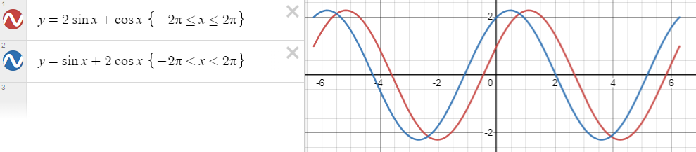
From the figure above, the graph for y = sin x + 2cos x, when A = 1 and B = 2, reveals another sinusoidal curve. The maximum point occurs at new x and y-values, which have shifted to the left compared to the previous graph, when A=2 and B=1.
#Question 5:
I discovered that switching A with B, and vice versa changes only the phase of the function, but not the amplitude. Therefore, changing A and B affect the position of the maximum point in the graph, altering its x-value. Nonetheless, despite the shifts, the maximum y-value remains constant for both cases. The relationship discovered when varying A and B moves the maximum point along the x-axis but maintain the same maximum y-value. This discovery shows that the maximum point of a function can be affected by coefficients even in a periodic function like $y = sin x + cos x$, but the highest y-value remains consistent irrespective of the shifts.

